##### **Asian Options Monte Carlo Pricing Using the Lévy Lognormal Approximation**

##### **Theo Dimitrasopoulos*, William Kraemer*, Snehal Rajguru**, Vaikunth Seshadri\***

* Department of Financial Engineering; Stevens Institute of Technology Babbio School of Business

** Department of Engineering Management; Stevens Institute of Technology School of Systems & Enterprises

Abstract—This paper investigates a number of popular methods for pricing Asian options: the Lévy Lognormal approximation and the Black-Scholes Model within a Monte Carlo implementation of arithmetic and geometric averaging methodologies. A multiple control variates technique is also implemented in the Monte Carlo Engine as a means of variance reduction in the price results. Several comparisons are drawn between the various techniques to benchmark the accuracy of each result and the speed of the corresponding algorithms. The Lévy Lognormal approximation provides a quick yet imprecise analytical framework for the geometric Asian option price, while the Monte Carlo implementations of the Black Scholes model with the appropriate variance reduction yields a remarkably accurate result at higher computation times. Multiple iterations of Monte Carlo engine input parameters are presented, and a time-efficient set of variables is benchmarked against popular case methods such as the Linetsky cases for arithmetic average Asian options [3].

Keywords—Arithmetic Average, Black Scholes Model, Brownian Motion, Control Variates, Derivatives Pricing, Geometric Average, Lévy Approximation, Lognormal Approximation, Monte Carlo Simulation, Options Pricing, Python, Statistical Modeling, Tensorflow.

# Introduction

Asian Options are an exotic derivative where the payoff is determined by the average price of the underlying asset over its maturity T i.e. path dependent contract. The payoffs of a fixed-strike Asian option at maturity T are defined as,

$C\left(K, T\right)=\left(K-{\overline{A}}_{T},0\right)^+$ 1

$P\left(K, T\right)=\left({\overline{A}}_{T}-K,0\right)^+$ 2

$$\overline{{\overline{A}}_{T}=\frac{\int_{0}^{T}{S_{t}dt}}{T} i.e. the continuous average price of the underlying asset.}$$

$$\underline{K=Strike price }$$

The average can be calculated arithmetically or geometrically, a detail that is explicitly stipulated in the option contract. For averaging in discrete time, are defined as,

$A_{N}=\frac{1}{N}\sum_{i=1}^{N}{S_{t_{i}}}$ 3

$G_{N}={(\prod_{i=1}^{N}{S_{t_{i}})}}^{\frac{1}{N}}$ 4

$$\overline{\underline{S_{t_{i}}=Underlying asset prices at times t_{i} for i=1,2,…,N}}$$

Asian options using arithmetic averaging are more common than those using geometric averaging. However, the advantages of a geometric average procedure make it a very appealing choice for quantitative modeling and will be discussed further in the following sections.

Most Asian option contracts in industry are known to be averaging-in style. Averaging-in style contracts will sample at discrete and regular time intervals i.e weekly, monthly, quarterly, or annually averaging from inception to maturity date. Conversely, if an Asian option is averaging-out style the average is computed using specific samples near the maturity date. Generally speaking, averaging-out style options are more risky than averaging-in style options since the uncertainty of future spot prices is higher the further in time from the start of the contract. Averaging-out style Asian options have an increased risk exposure to spot price and volatility which is reflected in their higher price.

Arithmetic Asian option prices can only be estimated using numerical methods such as Monte Carlo, since the arithmetic average of log-normal variables does not follow a log-normal distribution. In contrast, an analytical closed-form formula for Geometric Asian Options can be adapted from the Black-Scholes model, as geometric averages of log-normal variables also follow a log-normal distribution in a risk neutral world. Kemna and Vorst[2] offer a versatile approximation for a geometric Asian option using the Black-Scholes formula and will be discussed in the pricing algorithm section.

Compared to similar ‘vanilla’ exchange traded derivatives Asian options are attractive as their volatility is low due to the averaging mechanics of its payout. Consequently,  Asian options are less expensive than their corresponding vanilla derivatives. Furthermore, the higher number of observations, the lower the price of the Asian option. For this reason Asian options are a favored hedging tool of actors in volatile markets such as commodities, foreign exchange, and energy. Consider an airline that steadily buys crude oil whose supply price is not fixed, but set weekly from a particular benchmark. The airline may hedge themselves against a spike in oil by using a tailored Asian option to reflect the weekly purchases. This would be less expensive and more convenient than buying a basket of European options expiring at weekly intervals. However, Asian options are not limited to crude oil, but extend to many other commodity futures. Finally, Asian options are also be useful in markets with low volume, as the derivative would protect against price manipulation of the underlying asset.

# Materials and Methods

## Geometric Brownian Motion i.e. Black-Scholes Model

The underlying asset price is assumed to follow a stochastic process of a Geometric Brownian Motion (hereinafter GBM),

$S=rSdt+σSdz$ 5

$$\overline{S=price of the underlying asset}$$

$$r=risk-free interest rate$$

$σ=volatility$

$$\underline{dz=Wiener process }$$

A Wiener process has the following properties:

1. The change $Δz$ in a short period of time $Δt$ is,

$Δz=ε\sqrt{Δt}$ 6

$$\overline{\underline{where ε\sim N\left(0,1\right)}}$$

1. The values of $Δz$ for any two different short intervals of time $Δt$ are independent.

$N\left(x,y\right)$ denotes a normal distribution with mean $x$ and variance $y$. In discrete time terms, the change in the stock price from Eq. 5 & 6 becomes,

$ΔS=rSΔt+σSε\sqrt{Δt}$

$\frac{ΔS}{S}=rΔt+σε\sqrt{Δt}$

$\frac{ΔS}{S}\sim N(rΔt,σ^{2}Δt)$ 

7

Therefore, the rate of return of the stock price over a time interval Δt follows a normal distribution with mean rΔt, and standard deviation $σ\sqrt{Δt}$. Applying It $\hat{o}$’s lemma, if a stochastic variable X follows the It $\hat{o}$ process,

$dX=a\left(X,t\right)dt+b\left(X,t\right)dz$ 8

A function $f\left(X,t\right)$ follows the process,

$df=\left(\frac{∂f}{∂X}a+\frac{∂f}{∂t}+\frac{1}{2}\frac{∂^{2}f}{∂X^{2}}b^{2}\right)dt+\frac{∂f}{∂X}bdz$ 9

This can in turn be applied to the stock price process in Eq. 5 to define the continuous path,

$dln\left(S\right)=\left(\frac{1}{2}rS+0+\frac{1}{2}\left(\frac{-1}{S^{2}}\right)σ^{2}S^{2}\right)dt+\frac{1}{2}σSdz$

$dln\left(S\right)=\left(r-\frac{1}{2}σ^{2}\right)dt+σdz$ 

10

The equivalent of Eq. 10 in discrete time is therefore,

⬄

⬄

11

Eq. 9 is the GBM price path generator that is used to construct hypothetical trajectories of the price of the underlying asset. It is widely used in the Black Scholes model to model stock prices.

More specifically, the mean and variance of the price path (Fig 1.) represent the risk-free interest rate and the stock volatility of the underlying asset respectively. As a proof of concept, Fig. 2 shows the result of $n_{paths}=1,000$ price paths with $n_{steps}=10,000$ timesteps.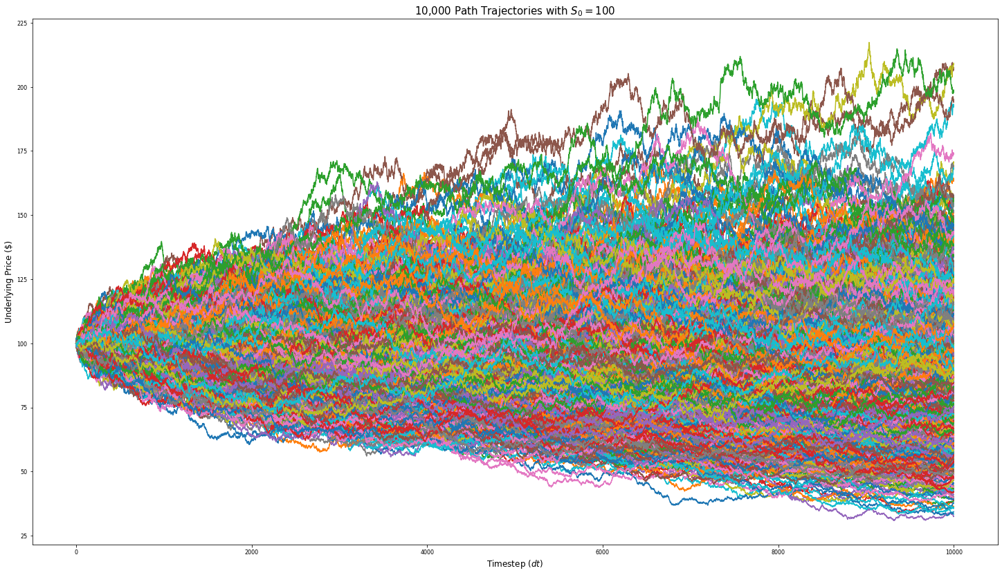 The path trajectories sufficiently mimic stock price trajectories seen in a stock market setting and will be used as the basis of subsequent operations in this paper with no further modifications.

## Log-normal (Lévy) approximation and $A_{N}$:

The valuation of Arithmetic average Asian options under standard assumptions poses various difficulties. Central to the valuation issue is, with the exception of trivial cases, the lack of closed-form solutions under the conventional geometric diffusion model for the underlying price process. In essence, the Lévy approximation solves the issue and enables a quick approximation of the value of arithmetic average Asian options. More specifically, the hypothesis that “the distribution of an arithmetic average is well-approximated by the log-normal distribution when the underlying price process follows the conventional assumption of a geometric diffusion”, is confirmed with tests that simulate volatility similar to real market conditions. [1].

The log-normal approximation arises from the moment matching procedure described in the Appendix wherein the mean $\left(M_{1}\right)$ and variance $\left(M_{2}\right)$ of $\int_{0}^{T}{S_{t}dt}$ in $P^{*}$ is,

$$μ_{lognormal}=\frac{\left(e^{rT}-1\right)}{rT}S_{0}$$

$$σ_{lognormal}=\frac{2S_{0}^{2}}{T^{2}\left(r+σ^{2}\right)}\left(\frac{e^{2r+σ^{2}}Τ-1}{2r+σ^{2}}-\frac{e^{rT}-1}{r}\right)-\left(\frac{e^{rT}-1}{rT}S_{0}\right)$$

The Monte Carlo Engine that replicates the BS model’s geometric Brownian motion trajectories in repeated succession draws from a log-normal distribution,

$$\backslash ln\{\backslash left(X\backslash right)\}\backslash sim\backslash mathcal\{N\}\backslash left(\backslash mu_\{lognormal\},\backslash sigma_\{lognormal\}^2\backslash right)$$

and goes beyond the log-normal assumption. The closed-form solution of the price in terms of $σ_{lognormal}$ and $μ_{lognormal}$ is,

$$A_{C}\left(K,T\right)=e^{-rT}\left[FN\left(d_{1}\right)-KN\left(d_{2}\right)\right]$$

$$A_{P}\left(K,T\right)=e^{-rT}\left[KN\left({-d}_{2}\right)-FN\left({-d}_{1}\right)\right]$$

Where,

$$d_{1,2}=\frac{\left(\ln{\frac{S}{K}}+\left(r±\frac{σ_{lognormal}^{2}}{2}\right)T\right)}{σ_{lognormal}\sqrt{T}}$$

$$F={S_{0}*e}^{μ_{lognormal}}$$

However, its accuracy is not sufficient and both methods are implemented and compared to each other to determine their strengths and limitations.

1. Arithmetic monte carlo pricer & linetsky benchmarks.

| **Case** | r | σ | S0 | Linetsky | Monte Carlo | % ε |
| --- | --- | --- | --- | --- | --- | --- |
| Ac(K,T)1 | 0.0200 | 0.10 | 2.0 | 0.0559860415 | 0.0559778385 | 0.0147 |
| Ac(K,T)2 | 0.1800 | 0.30 | 2.0 | 0.2183875466 | 0.2170470505 | 0.6138 |
| Ac(K,T)3 | 0.0125 | 0.25 | 2.0 | 0.1722687410 | 0.1726129894 | 0.1998 |
| Ac(K,T)4 | 0.0500 | 0.50 | 1.9 | 0.1931737903 | 0.1917548655 | 0.7345 |
| Ac(K,T)5 | 0.0500 | 0.50 | 2.0 | 0.2464156905 | 0.2472542514 | 0.3403 |
| Ac(K,T)6 | 0.0500 | 0.50 | 2.1 | 0.3062203648 | 0.3066361640 | 0.1357 |
| Ac(K,T)7 | 0.0500 | 0.50 | 2.0 | 0.3500952190 | 0.3475691276 | 0.7215 |

## The modified Black-Scholes Model:

In the case of Geometric Average Asian Options, the Black-Scholes options pricing model (hereinafter referred to as BS model) is fully compatible and can be solved in closed-form. This arises from the inherent log-normality of the two distributions. Therefore, the modified BS model for geometric average call and put options is defined as shown in Fig. 3.

The modified volatility $Σ_{G}$ allows for the treatment of Asian options as European options with a decreased volatility by a factor of $\sqrt{3}$.

Under the Lévy approximation [1], the accuracy of both arithmetic and geometric average Asian options can be measured through direct comparisons with the closed form BS model. This confirms the shared lognormality of the geometric average and enables additional stress test against arithmetic average contracts, which are more commonly used in industry.

1. greeks capabilities of the mc & BS algorithms.

|  | Asset Price (S) | Volatility (σ) | Expiry (T) |
| --- | --- | --- | --- |
| Option Price | Delta (**Δ**) | Vega (**V**) | Theta (**Θ**) |
| Delta (**Δ**) | Gamma (**Γ**) | Vanna (D**Δ**D**σ**) | Charm (D**Δ**D**t**) |
| Vega (**V**) | Vanna (D**V**D**S)** | Volga (D**V**D**σ**) | Veta (D**V**D**t)** |
| Gamma (**Γ**) | Speed (D**Γ**D**S)** | Zomma (D**Γ**D**σ**) | Color (D**Γ**Dt) |
| Vomma (D**V**D**σ**) | N/A | Ultima(D**Vom**Dσ) | Totto (D**Vom**D**t**) |

## Monte Carlo Simulator

Monte Carlo experiments (hereinafter referred to as MC) are a class of computational algorithms that optimize a numerical result of a deterministic problem through the use of repeated random

sampling. In summary, the following steps are executed in an MC simulation,

* define the input domain for the task;
* draw random inputs from given probability distribution;
* compute the numerical result for a number of iterations;
* aggregate the results.

The GBM Generator implementation creates the aforementioned random sample and computes the price paths. The particular definition in this paper takes the GBM path array, averages the prices along each path using both an arithmetic and geometric mean, calculates the price of the call or put option and aggregates the option prices by taking the average value. An additional property of the definition allows for variance reduction through the use of the geometric average payoff as a control variate for the arithmetic average. The difference of the two averaging methods is then added back to the arithmetic average to generate narrower confidence intervals and better approximate the true mean of the option price. The functions are divided in separate definitions to optimize computational performance, but Fig. 4 presents the general definition for arithmetic and geometric average Asian Call and Put options. Each simulation invokes the GBM function for a given number of iterations and generates an average payoff over the number of simulations. The final result then becomes the average MC price estimate of the option.

## Path-wise Greeks Derivations

Equivalent implementations of the Monte Carlo experiment above were constructed in Python’s Tensorflow framework. Tensorflow enables parallel computation for expensive tasks by sending packages to a Graphics Processing Unit (GPU) or a Tensor Processing Unit (TPU). Executing the algorithm within the Google Colaboratory Graphical User Interface allowed the use of Google’s GPU and TPU units for the calculation of the numerical result. This enabled the computation of path-wise Greeks for both arithmetic and geometric average call and put options. Fig. 5 shows the exact python definition of the algorithm, as a pseudocode interpretation of the Tensorflow definitions was extremely verbose. The algorithm generates average values of Greeks across all simulations and stores them in arrays. Table I Illustrates the Greeks generated in a convenient mnemonic rule.

## Greeks in the Black-Scholes Model

The definition has been updates to include numerical and graphical representations of Greeks in order to better assess the sensitivities of the options contracts under evaluation. Table I shows the BS Greeks capabilities in the algorithm (underlined). In addition, it includes Rho (**ρ**), or the sensitivity of an option or an options portfolio to changes in the risk-free rate interest rate, as well as Phi (**φ**), or the expected change in the option premium due to small changes in the foreign currency interest rate, when applicable. All options calculations have been adjusted for the modified BS model, and $Σ_{G}$ (Eq. 17) in particular. Fig. 7 & 8 present the Greeks surfaces for a range of underlying price ($S_{0}$) and maturity (**T**) values of a call and put options under the BS model.

# Results & Discussion

Asian options are rarely traded on an underlying stock of a publicly traded company within NYSE or NASDAQ making information on these options impossible to obtain from Yahoo Finance. However, these options are commonly used on commodities, most commonly on oil futures. This information is commonly available on CME (Chicago Mercantile Exchange). Due to the lack of a personal of corporate/institutional membership to their data service, using CME options data as a benchmark for the options proved to be difficult. However, within the scope of this research, the analytical results are computed and minimized through a series of cross-referencing and variance reduction techniques in order to estimate sufficiently accurate option prices without the need for data extraction with cumbersome data wrangling procedures. Fig. 17 shows the results of the log-normal MC engine.

## Linetsky vs. Arithmetic MC

Linetsky [2] offers a set of test cases that has become the leading standard in the research literature with regards to calibration and accuracy test hypotheses. Using the eigenfunction expansion approach, the approximation yields results deemed to be the most accurate arithmetic average computation. The comparison of the Monte Carlo Arithmetic Average Options algorithm agrees with the test results within a range of absolute errors,

$\left[0.0147\%,0.7345\%\right]$ 14

The error was minimized first, by increasing the number of price paths generated by the GBM function; second, by incrementally increasing the number of Monte Carlo simulations; third, by determining the optimal number of timesteps given the available timeframe. The numerical combination to minimize the errors that stem from insufficient sampling are shown in Fig. 6 and were

identified through trial-and-error. The combination was used in all experiments, unless shown otherwise.

## BS Model vs. Geometric MC

In the case of the Geometric Average pricing algorithm, the results are compared with the BS model numerical outputs and graphs of Greeks and graphs of the call option values across time to expiry (T), incremental values of the risk-free interest rate, volatility cases and others. Fig. 10 illustrates the BS model results and Fig. 12 illustrates the equivalent cases from the MC Call Options under the combination of MC model parameters in Fig. 6. The results for three cases of call and put options with strikes $K=95, 100, 105$ are summarized in Table II. Employing the solution to the geometric average problem leads to underpricing in put and/or overpricing in call options [2]. However, the errors are within the range,

$\left[0.2047\%,0.5438\%\right]$ 15

which was deemed sufficient for the purposes of this benchmark.

1. Geometric monte carlo pricer & BS benchmarks.

| **Gtype(K, T)** | BS | Monte Carlo ($G_{n}$) | % error (ε) |
| --- | --- | --- | --- |
| Gc(95,1.0) | 12.50853848101788 | 12.46260400000000 | **0.367228** |
| Gc(100,1.0) | 9.61215966961383 | 9.638977665500253 | **0.279001** |
| Gc(105,1.0) | 7.185865725921304 | 7.171154551742235 | **0.204724** |
| Gp(95,1.0) | 2.194652455717919 | 2.198018800000000 | **0.153388** |
| Gp(100,1.0) | 3.6018135264391495 | 3.610188200000000 | **0.232514** |
| Gp(105,1.0) | 5.479059464871914 | 5.489564400000000 | **0.191729** |

## Variance Reduction

A variance reduction technique is employed to define the confidence intervals of the mean option price and to reduce the potential errors of averaging across each simulation and the geometric average option payoff is used as a control variate to calibrate the accuracy of the arithmetic average component of the algorithm. This can be done by subtracting the geometric average option value from the equivalent arithmetically average counterpart, and then adding the geometrically averaged result back into the final option value. A second experiment was conducted using the difference between the option values of each averaging method and then tracking the confidence intervals at each step to obtain a descriptive set of the deviations between them. The differences become smaller along each timestep, further confirming the efficacy of the variance reduction technique in approximating the true mean of the option value. Using the same visualization script as the BS results in III.B, the result of the control variates case of the MC method is evaluated and plotted against a range of market variables (Fig. 12).

## Other MC method error estimates

If the probability density of estimator $y$ is $f\left(y\right)$, its expected value is,

$μ_{y} ≡E\left(y\right)=\int_{-∞}^{∞}{y f\left(y\right)dy}$ 16

For $n_{sim}$ trials, we can use the sample mean as an estimator for $μ_{y}$,

$\overline{y}≡\frac{1}{N}\sum_{i=1}^{N}{y_{i}}$ 17

The moments of the error are,

$=E\left(\overline{y}-μ_{y}\right)=E\left(\overline{y}\right)-μ_{y}$

$=E\left(\frac{1}{N}\sum_{i=1}^{N}{y_{i}}\right)-μ_{y}$

$=\frac{1}{N}\sum_{i=1}^{N}{E\left(y_{i}\right)}-μ_{y}$ 

19

Due to the random sampling aspects of Monte Carlo methods, $E\left(\overline{y}\right)=μ_{y}$. Therefore,

$E\left(\overline{y}-μ_{y}\right)=\frac{1}{N}Nμ_{y}-μ_{y}=0$ 20

$μ_{\overline{y}}≡E\left(\overline{y}\right)≡μ_{y}$ 21

In other words, the error of evaluating $μ_{y}$ using $\overline{y}$ as an estimator is zero, and the estimator $\overline{y}$ is *unbiased*. For the variance,

⬄



⬄



⬄

⬄

22

Eq. 22 illustrates the interesting relationship between the standard error $σ_{\overline{y}}$ of the estimator and the sample size $N$ i.e. the standard error decreases with $\sqrt{N}$. In terms of the Monte Carlo Engine, this finding aids in reducing unnecessary computation and setting bounds on the minimum number of paths needed to achieve optimality. To reduce the standard error in the experiment, the sample size was increased by a factor of 1,000 from the original sample. For the variance reduction implementation, the sample size was increased by a factor of 100 for satisfactory results, and to meet computational constraints.

## Hedging Analysis

The analysis follows an Asian call option with stock underlying prices $S_{i}$ generated by the GBM price path generator across 5 consecutive days. The following assumptions are being made,

* Each path is refined to approximately 11 updates/second. The calculation assumes that price movements occur evenly throughout a 24-hour cycle.
* After-hours trading does not move the closing price of the security each day i.e. the price of the security at 9:30am (open market) is the same as the closing price the previous day.
* The security pays no dividend.

Each option represents a contract for one of 5 business days. Using the Greek letter derivatives property of the pricing algorithm, the static call option delta, $Δ\left(t_{i}\right)$ is obtained for each day and is used to create a second portfolio with option values,

$C\left(t_{i}\right)-Δ\left(t_{i}\right)S_{i}$ 23

The portfolio construction based on Eq. 23 is called a *delta-hedged portfolio* and exhibits the unique property of protecting the bundle against directional risk from volatility changes in the price of the underlying asset. The Asian call option delta is shown in Figure 3; it represents the rate of change of the option premium when the underlying asset price changes, and the number of shares required to maintain the overall traders’ position delta neutral.

The $C\left(t_{i}\right)$ plot of the two portfolios across time illustrates the additional protection of a delta-hedged portfolio (Fig. 13 and 14) as seen in the greatly reduced variability of the hedged portfolio throughout the week, as opposed to the naked portfolio. Asian options are easier to hedge than regular options as the payoff from an Asian option becomes more certain with the passage of time. As a result, the amount of uncertainty that needs to be hedged decreases with the passage of time. Delta-hedging is a very common options strategy and is very often paired with gamma hedging in a delta-gamma hedging strategy, which combines both delta and gamma hedges to protect against the risk of price changes in the underlying asset and the delta itself.

# Next Steps

Time permitting the team would have liked to incorporate additional properties to the algorithm in order to more accurately reflect on the price dynamics of an Asian stock. One potential path forward is the implementation of a local or stochastic volatility model that allows for a volatility surface feature; as such, it would generate more realistic results than those of a Lévy-approximation or Black-Scholes based model (where the volatility is static across the entire surface i.e. the plane, $z=σ\sqrt{3}$**.** Finally, we hope to test the pricing algorithm against real data and to take advantage of the unprecedented circumstances in the oil futures markets by incorporating data and features relevant to valuation in similar black-swan events.

Other Asian Options pricing algorithms developed over the years include, but are by no means limited to:

* Path Integral Approach - Effective Classical Potential
* Rogers & Shi’s PDE
* Jump Models (e.g. Variance Gamma Model)

It would be a fascinating endeavor to incorporate more functionality in the pricing algorithm and be able to price options more accurately and efficiently. The hope of this paper is to generate additional questions and research on the topic and provide more efficient tools and methodologies to industry professionals.

##### **Acknowledgments**

We would like to thank Professor Dan Pirjol for his invaluable guidance throughout this project; the Stevens Financial Engineering Department for providing us with remote Bloomberg Terminal access; and the Google Colaboratory and Google Compute service providers for enabling large-scale options pricing models at minimal costs for researchers.

##### **Authors**

**Theo Dimitrasopoulos**– MSc. Financial Engineering, Stevens Institute of Technology 2021; Bachelor of Science in Engineering, Structural Engineering, Princeton University 2017; [*theonovak.com*](http://theonovak.com/); [*tdimitr1@stevens.edu*](mailto:tdimitr1@stevens.edu)

**William Kraemer**– MSc. Financial Engineering, Stevens Institute of Technology 2020; BEng. Engineering Management, Stevens Institute of Technology 2019; *wkraemer@stevens.edu*

**Snehal Rajguru**– MEng. Engineering Management, Stevens Institute of Technology 2021; BEng. Electronics and Telecommunication Engineering, Pune University 2018; *srajguru@stevens.edu*

**Vaikunth Sheshadri**– Master of Science in Financial Engineering, Stevens Institute of Technology 2021; Bachelor of Science in Industrial Engineering, University of Wisconsin-Madison 2019; [*vseshadr@stevens.edu*](mailto:vseshadr@stevens.edu)

##### **References**

1. E. Lévy, (1992), “Pricing European average rate currency options”, Journal of International Money md Finance, 1992, vol. 11 pp. 474-491.
2. Kemna, A.G.Z. & Vorst, A.C.F. (1990), "A pricing method for options based on average asset values". Journal of Banking & Finance, Elsevier, March 1990, vol. 14(1), pp 113-129.
3. V. Linetsky (2002), Spectral Decomposition of the Option Value. Published as "[Exotic Spectra](http://users.iems.northwestern.edu/~linetsky/exoticspectra.pdf)", RISK, April 2002, pp.85-89.
4. Laura Ballotta, Russell Gerrard & Ioannis Kyriakou (2017). Hedging of Asian options under exponential Lévy models: computation and performance, The European Journal of Finance, 23:4, 297-323.
5. Yor, M. (2001). Exponential Functionals of Brownian Motion and Related Processes. Springer-Verlag, New York.
6. Pirjol, D., & Zhu, L. (2017). “Asymptotics for the discrete-time average of the geometric Brownian motion and Asian options”. Advances in Applied Probability, vol. 49(2), pp. 446-480.
7. Fu, Michael & Madan, Dilip & Wang, Tong. (1999). Pricing Continuous Asian Options: A Comparison of Monte Carlo and Laplace Transform Inversion Methods. J. Comp. Finance. 2. 10.21314/JCF.1998.024.

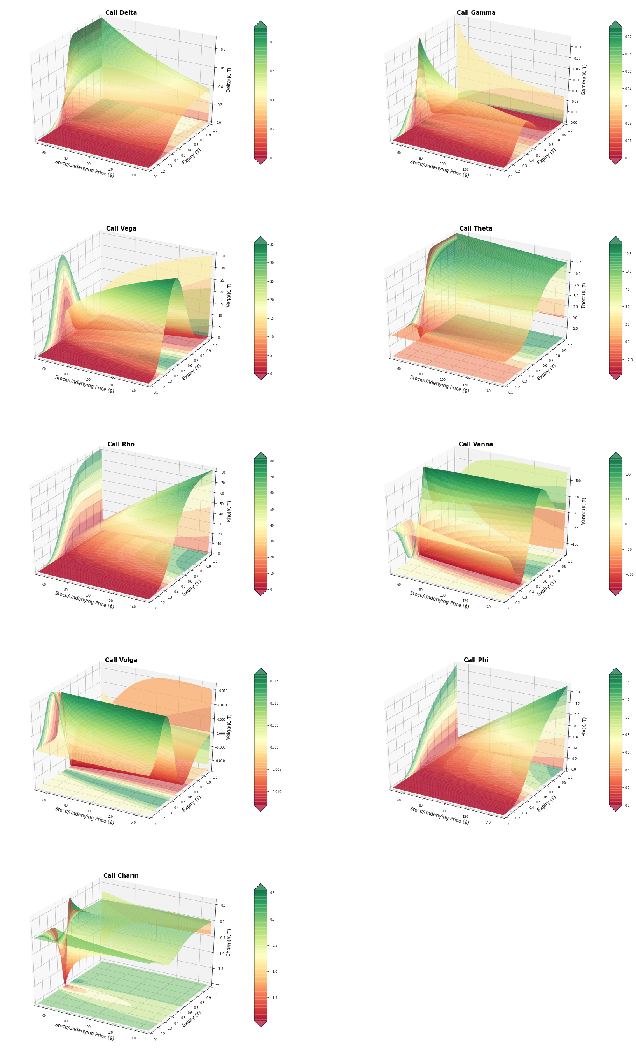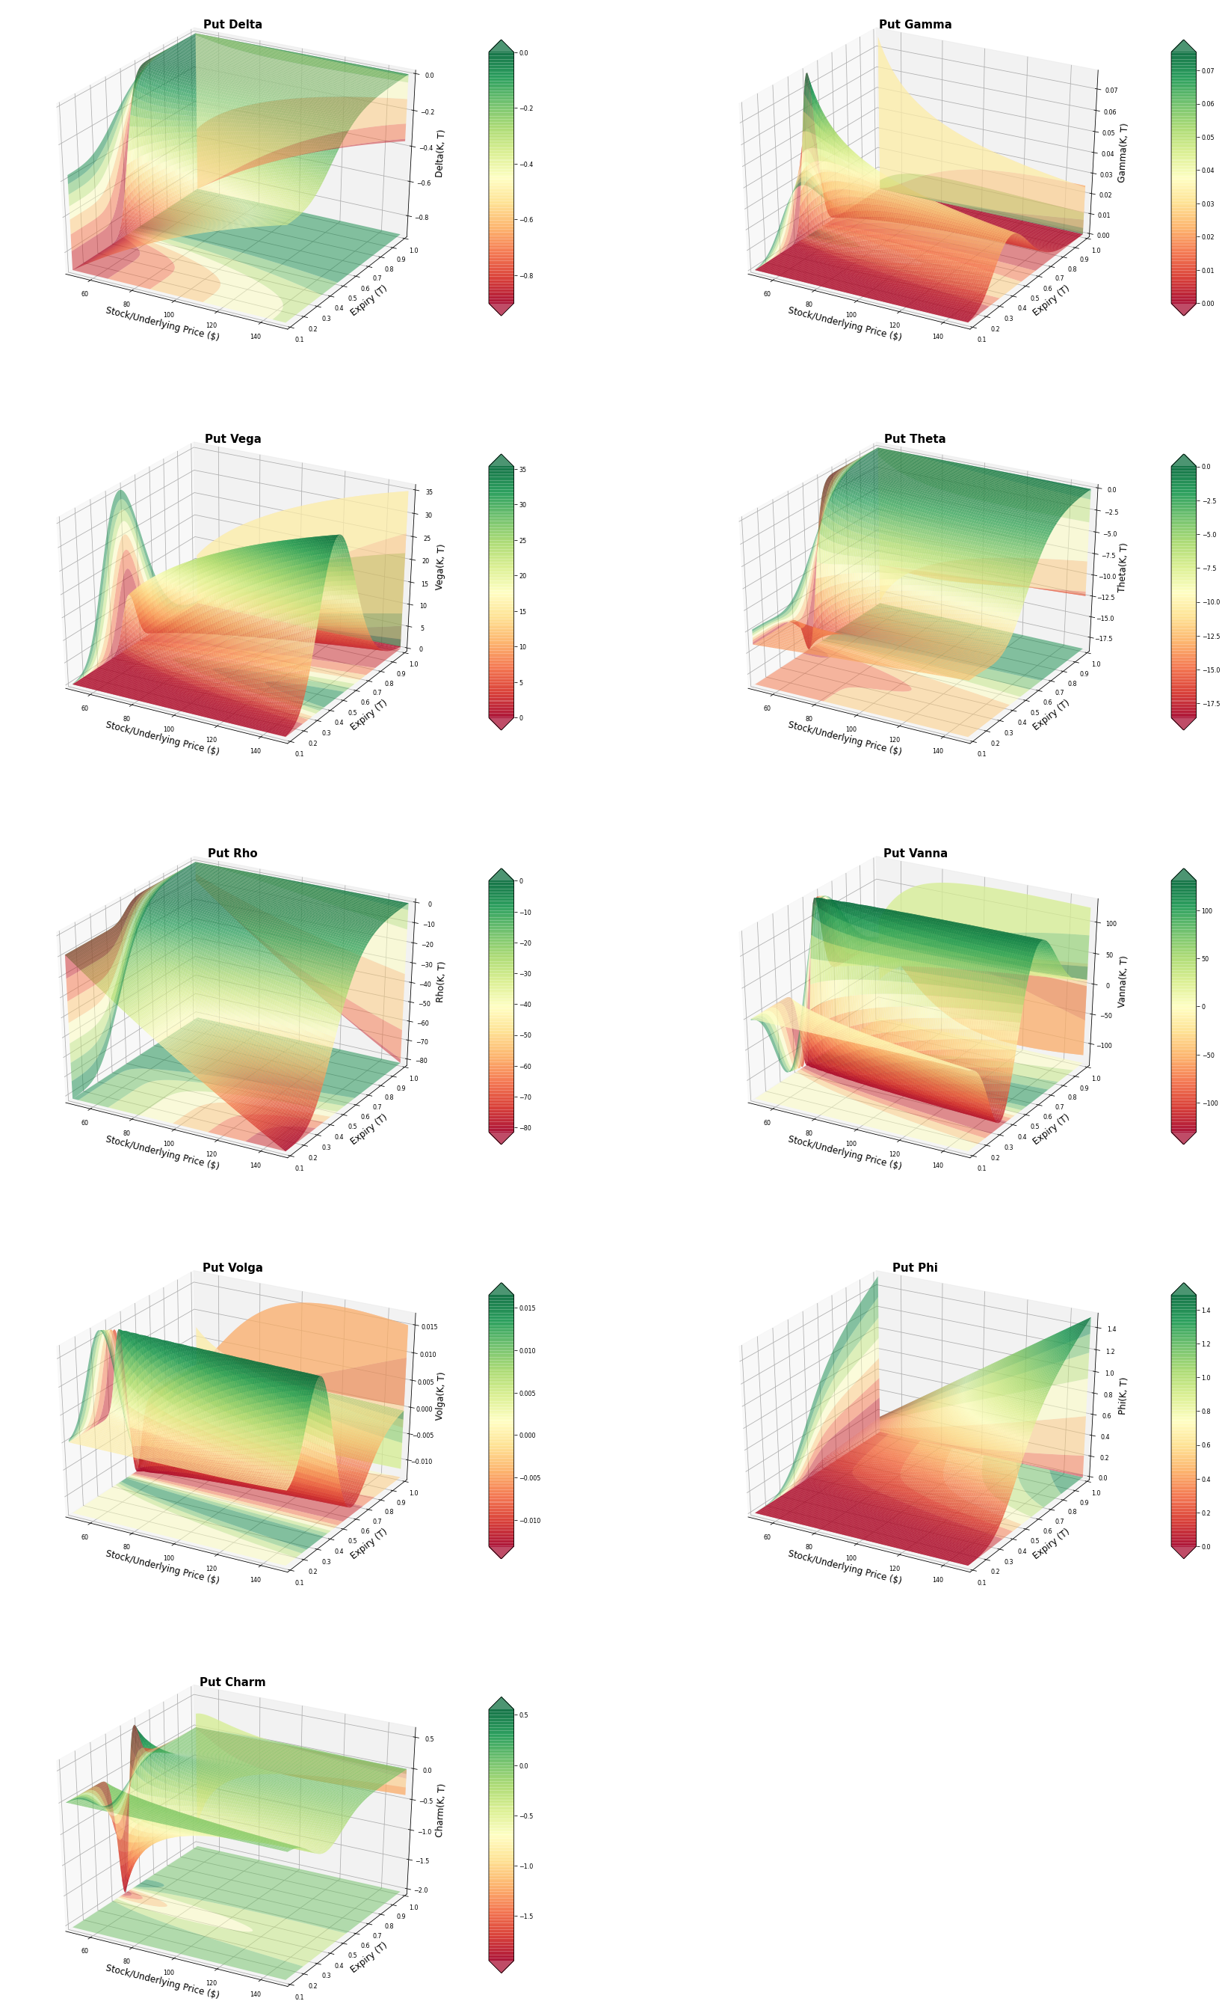

##### 

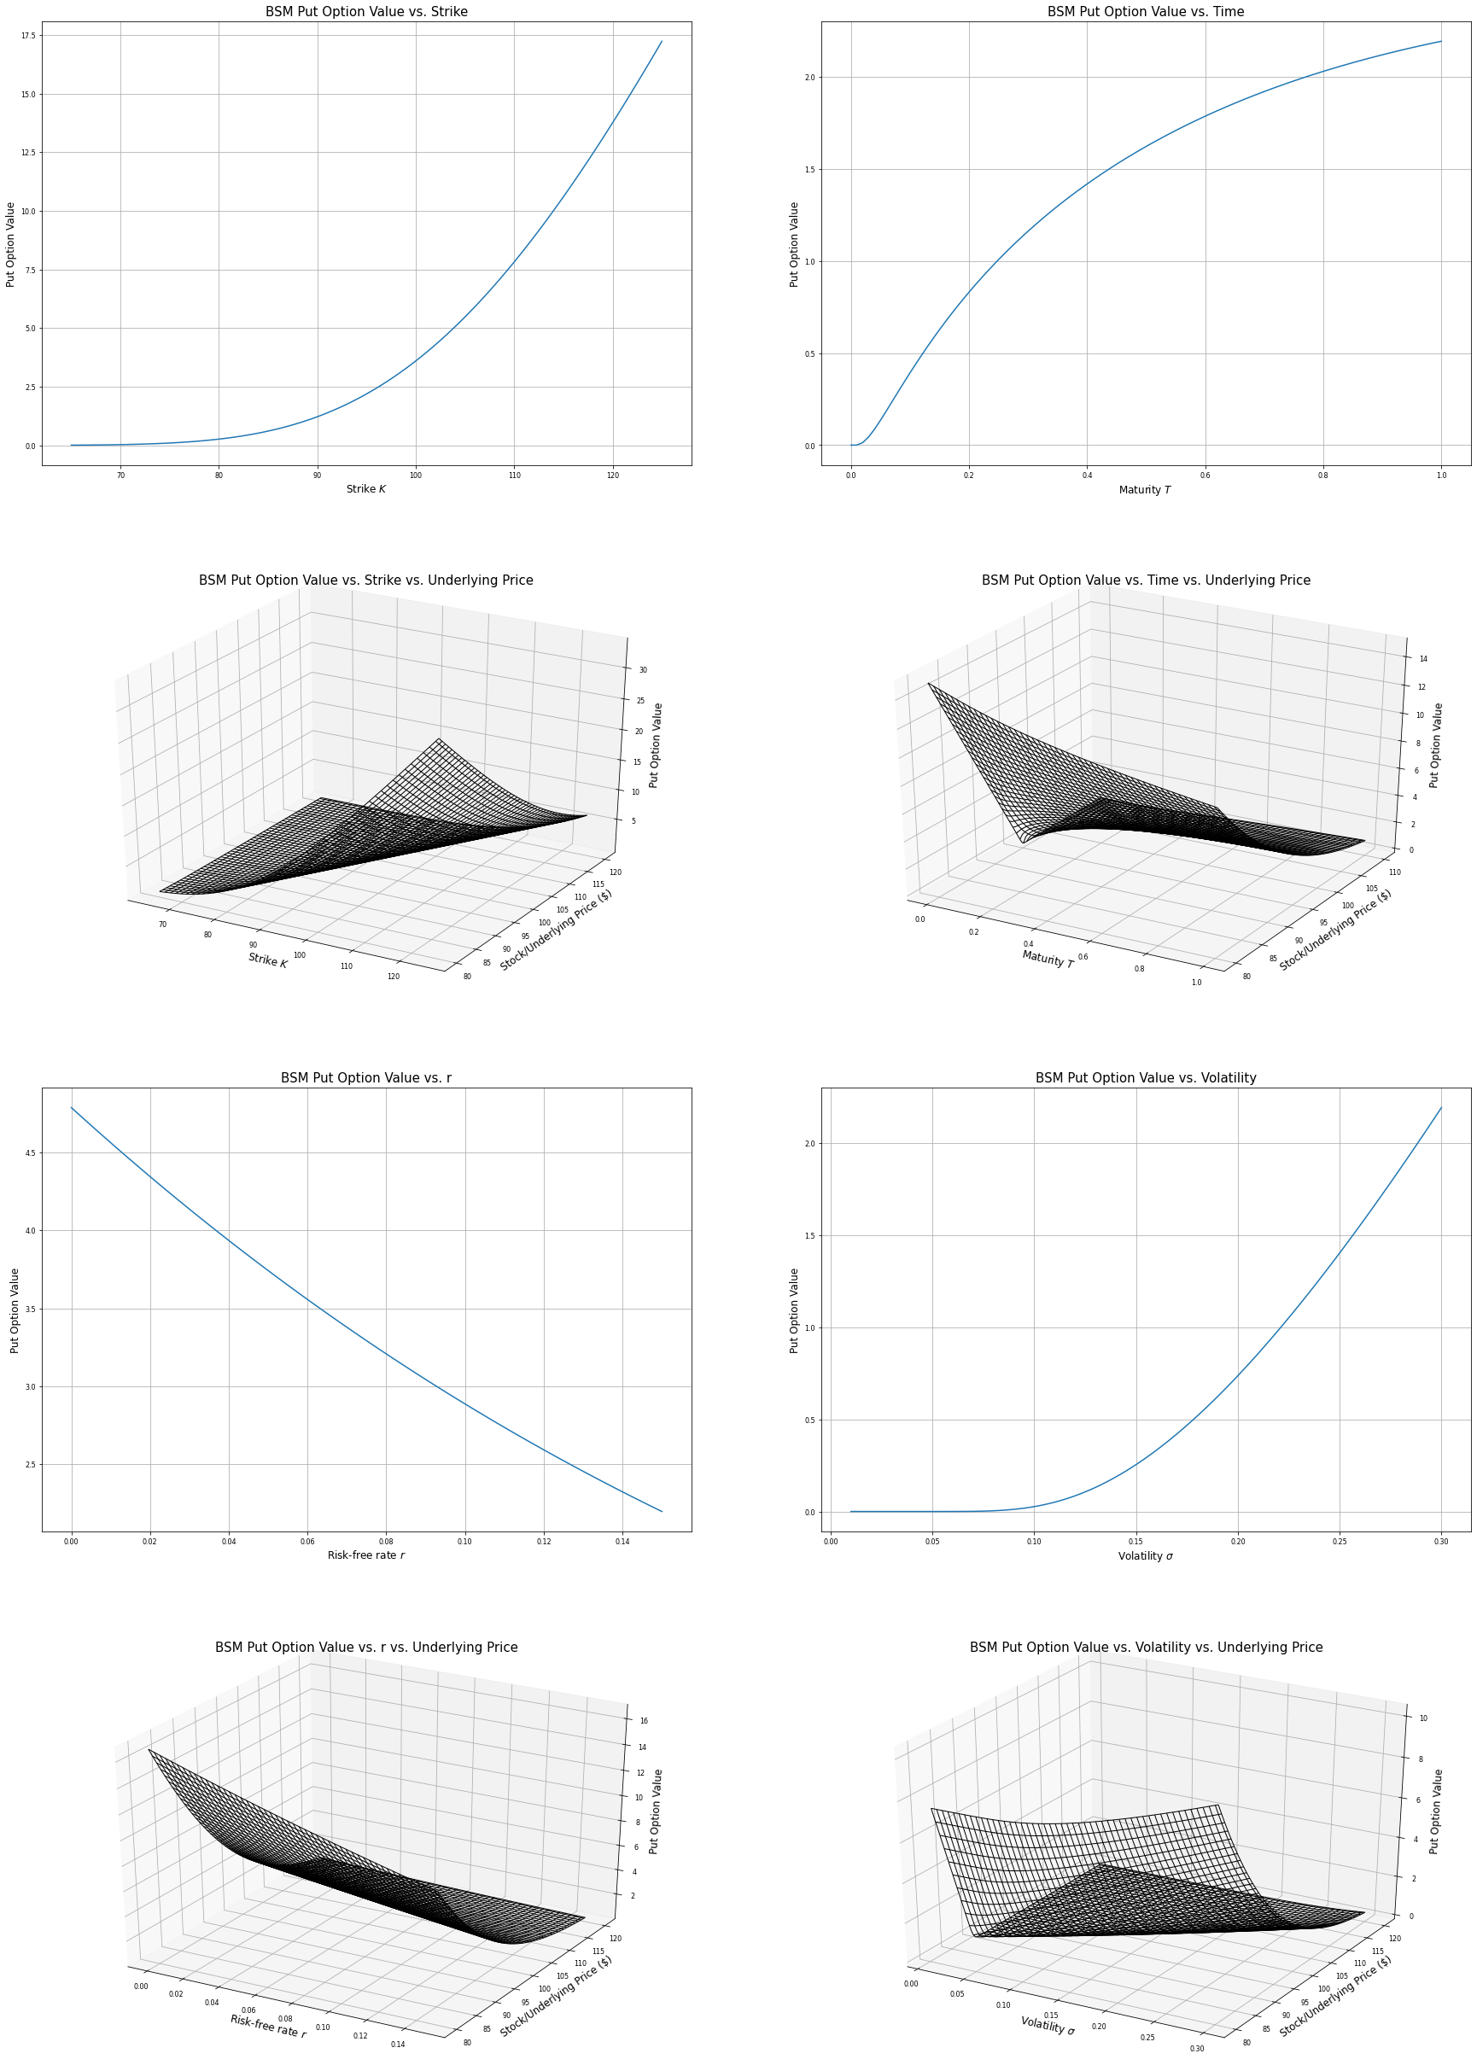

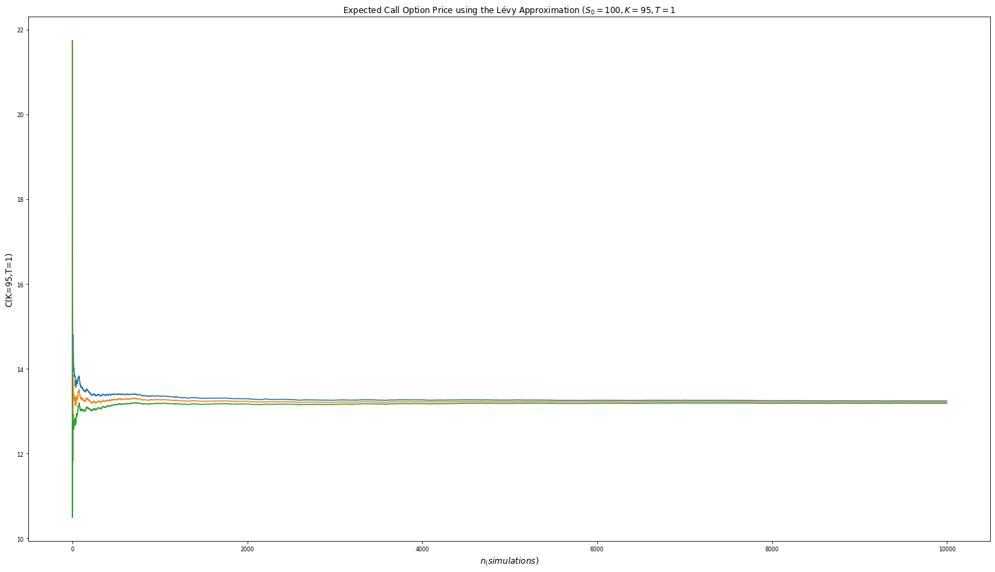

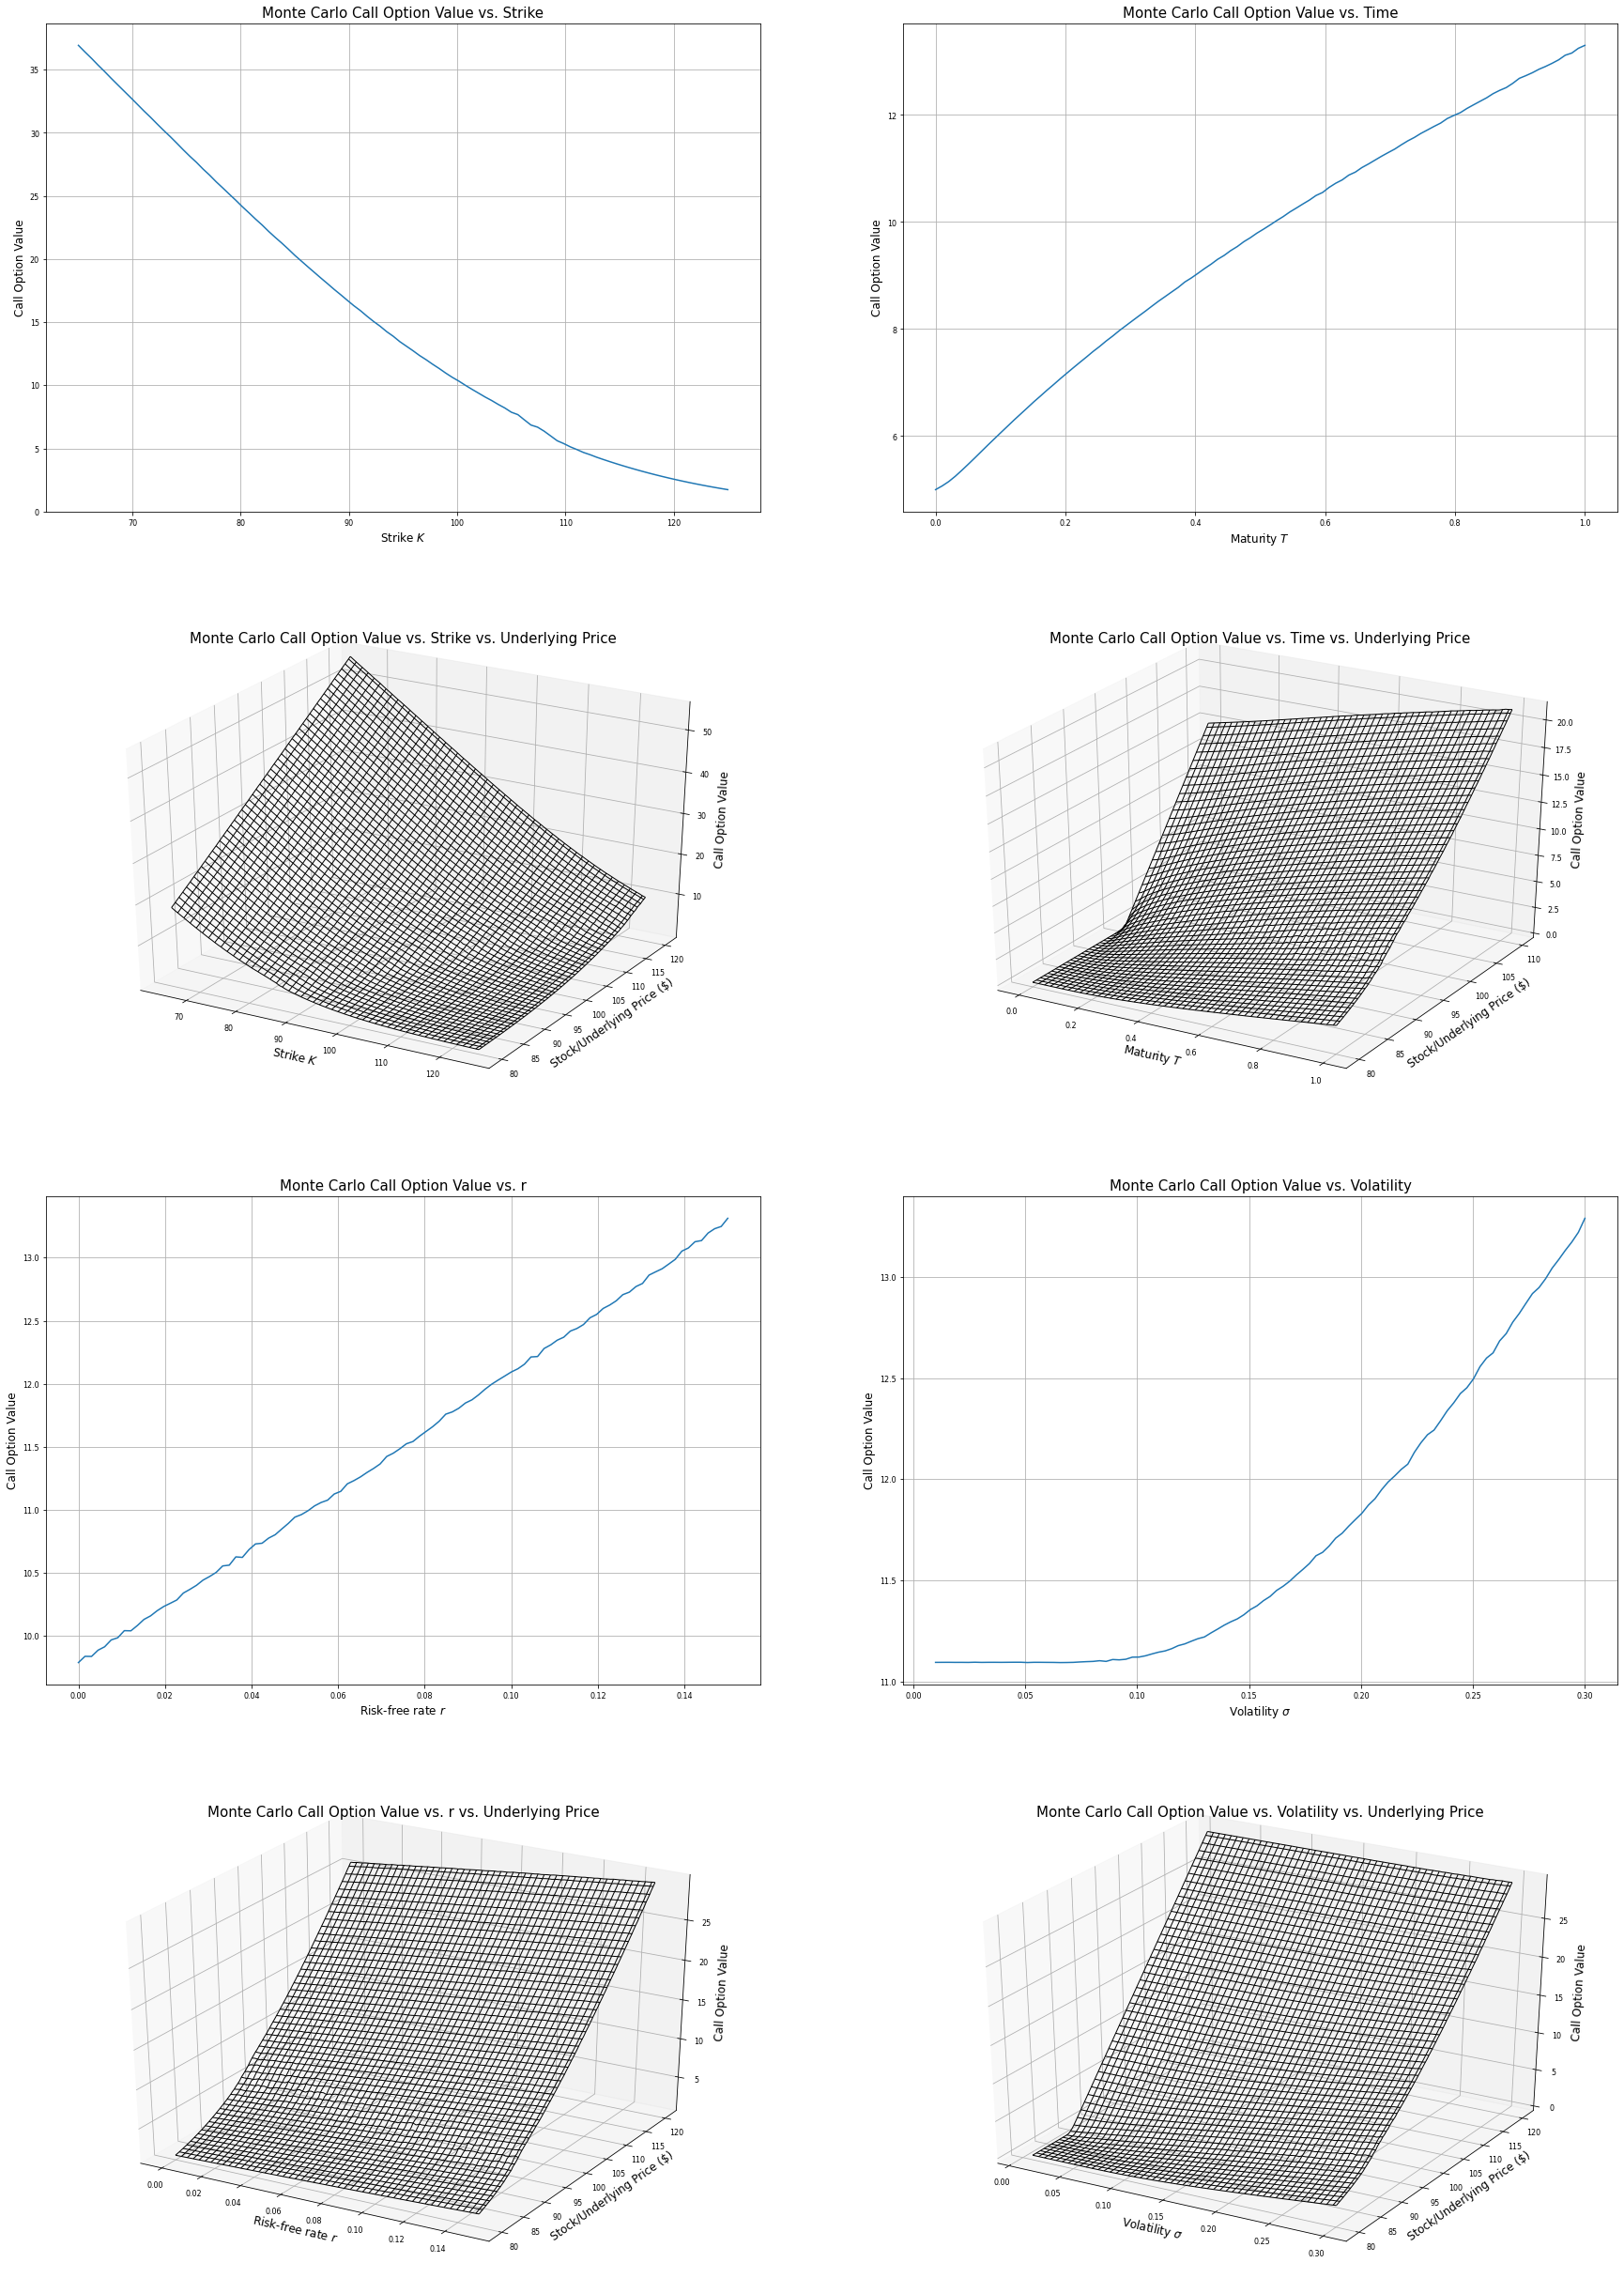

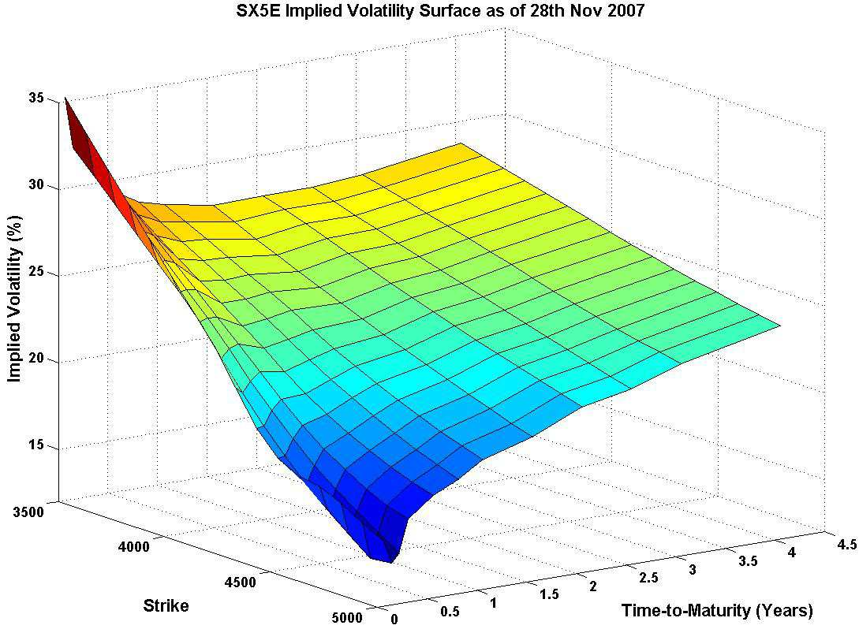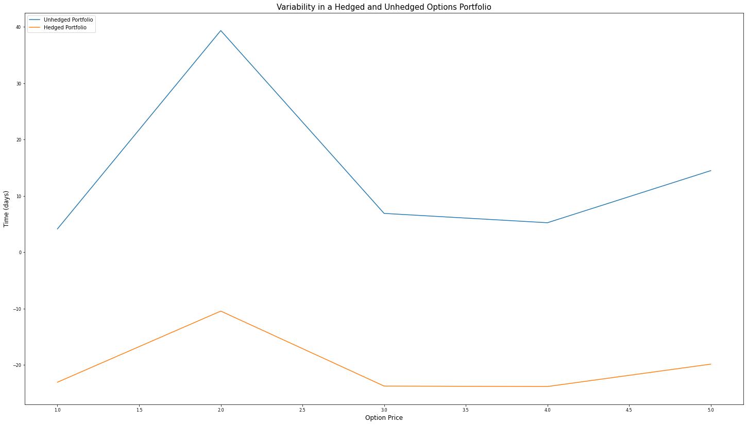

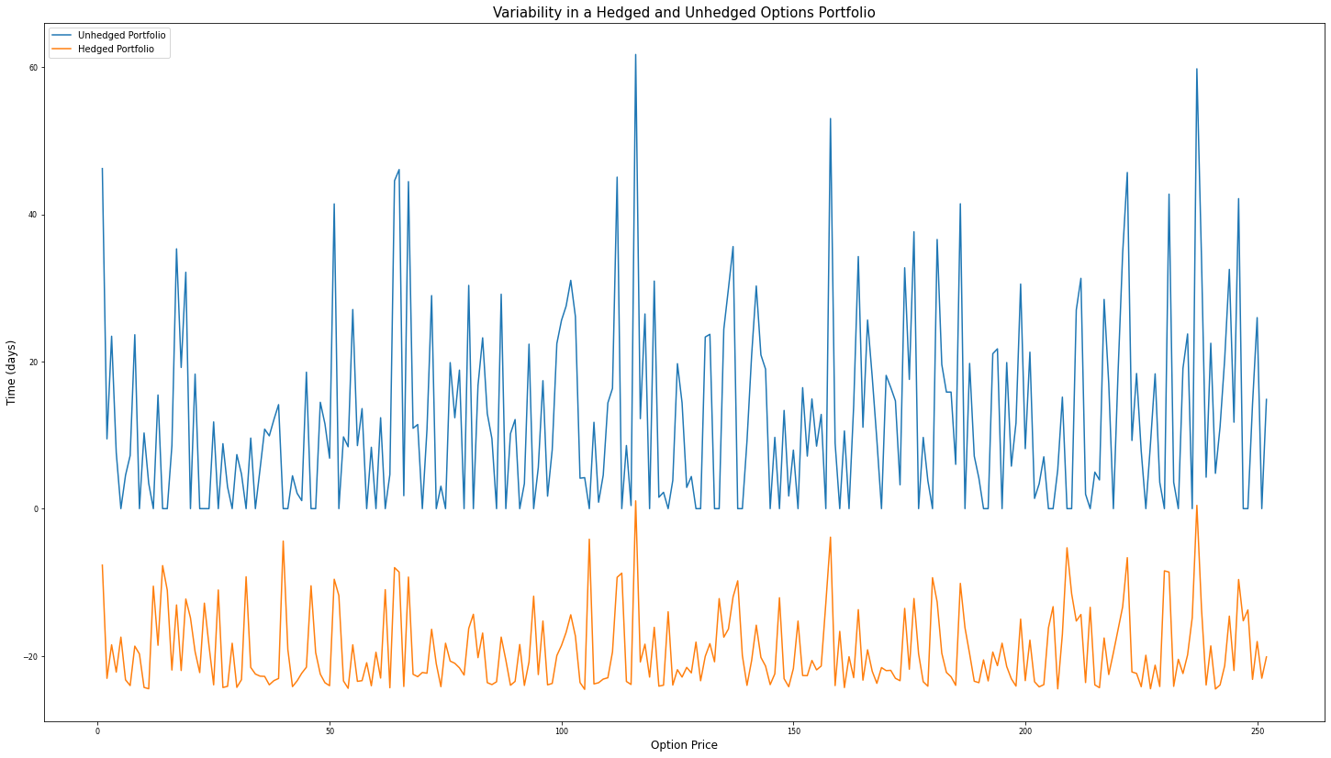

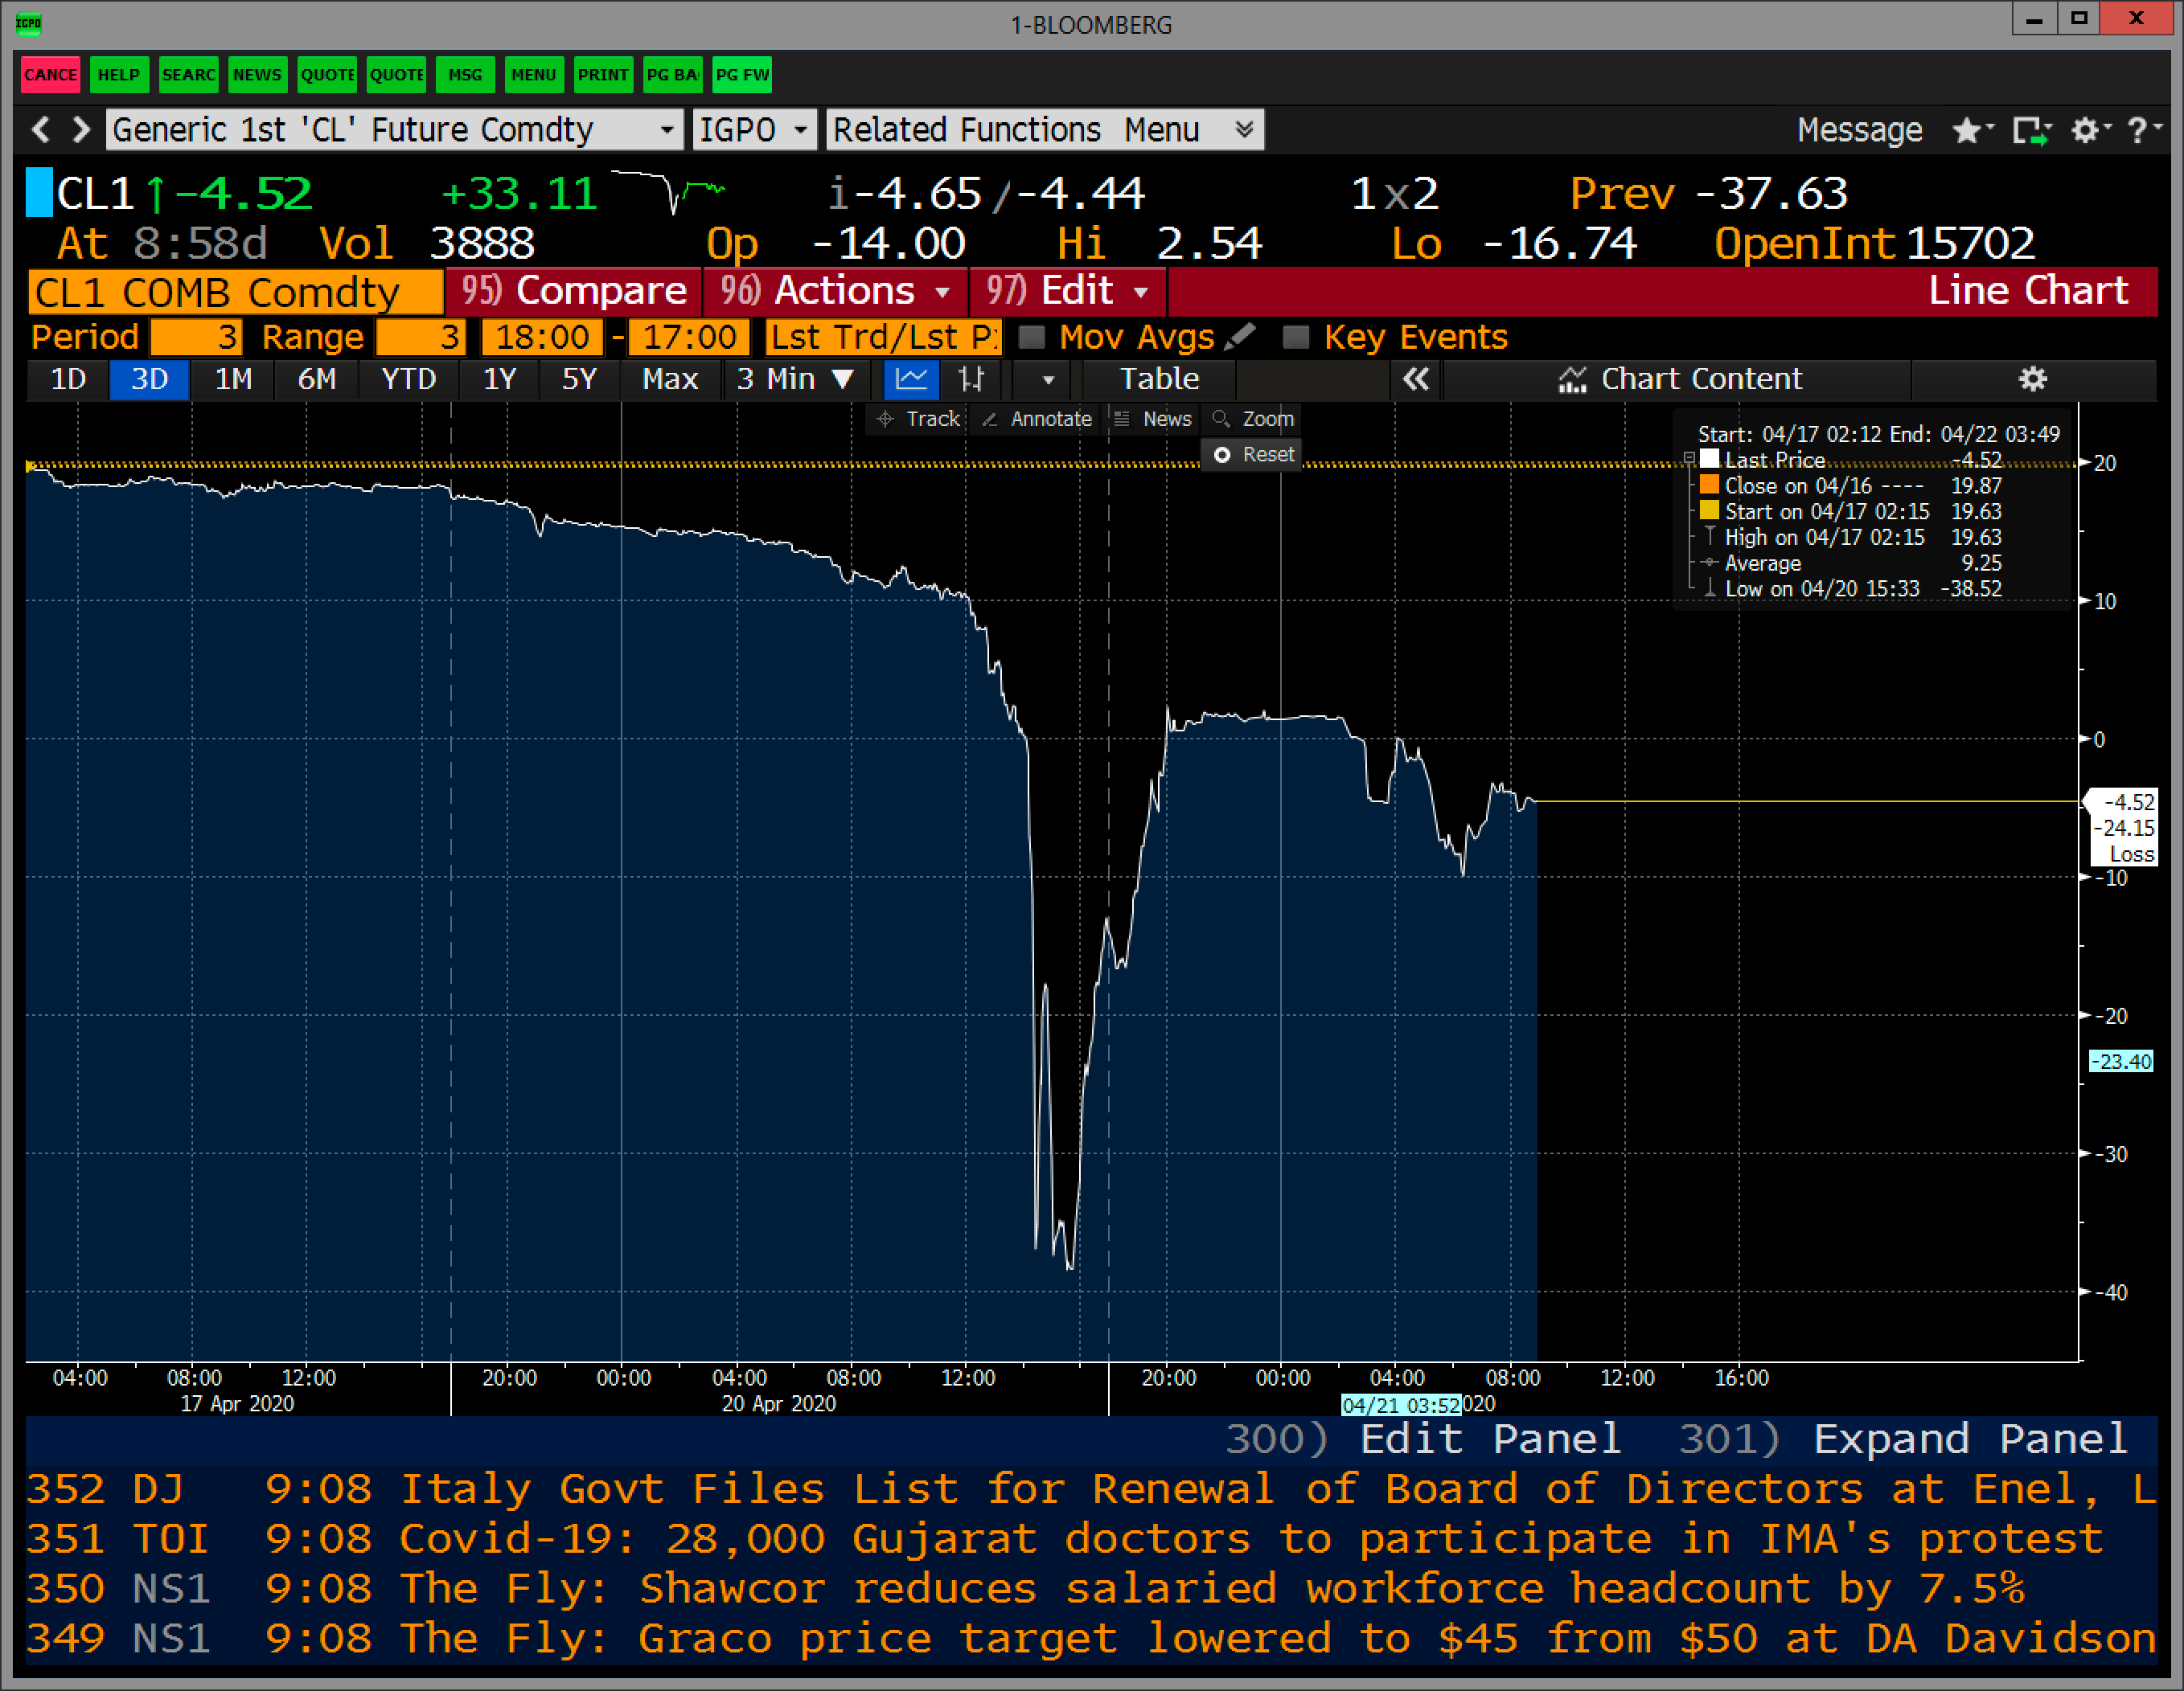

##### **Derivations**

The following is the calculation of the first and second moments i.e. the

mean and variance of the general Martingale shown in Eq. 11:

$$S_{t+\text{Δt}}=S_{t}*e^{σε-\frac{σ^{2}}{2}t}$$

The mean $\left(M_{1}\right)$ of $\int_{0}^{T}{S_{t}dt}$ in $P^{*}$:

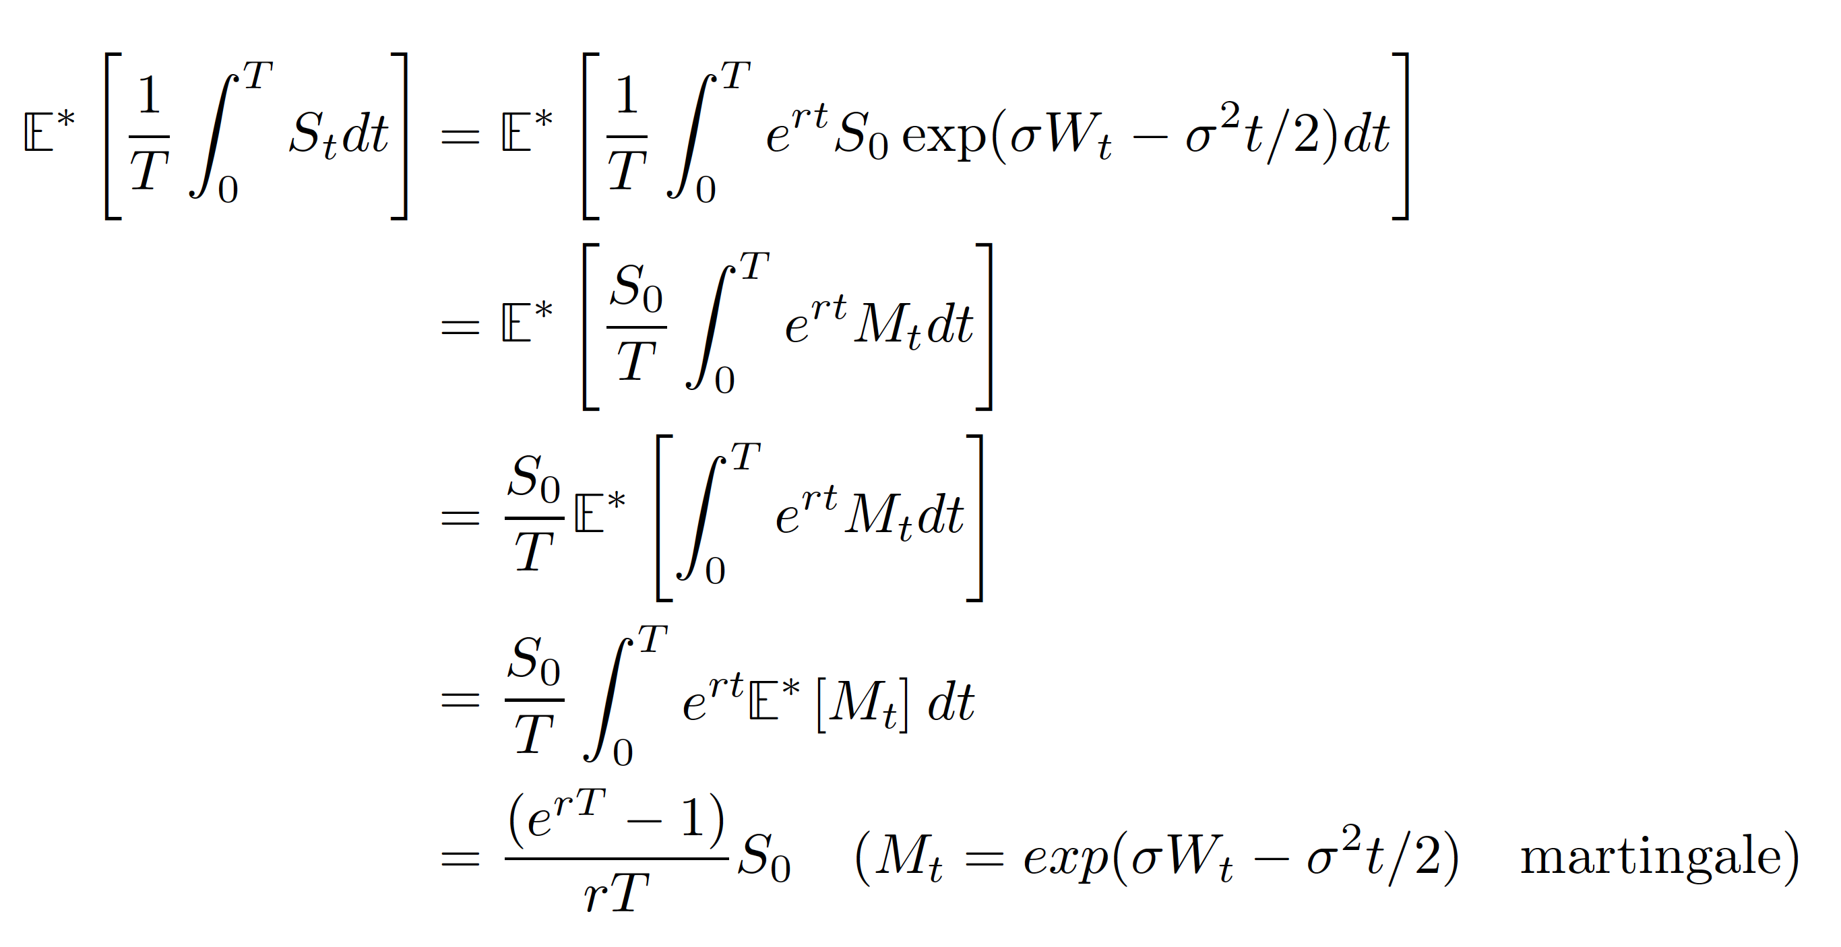

>>Imported from MacTeX

The variance $\left(M_{2}\right)$ of $\int_{0}^{T}{S_{t}dt}$ in $P^{*}$:

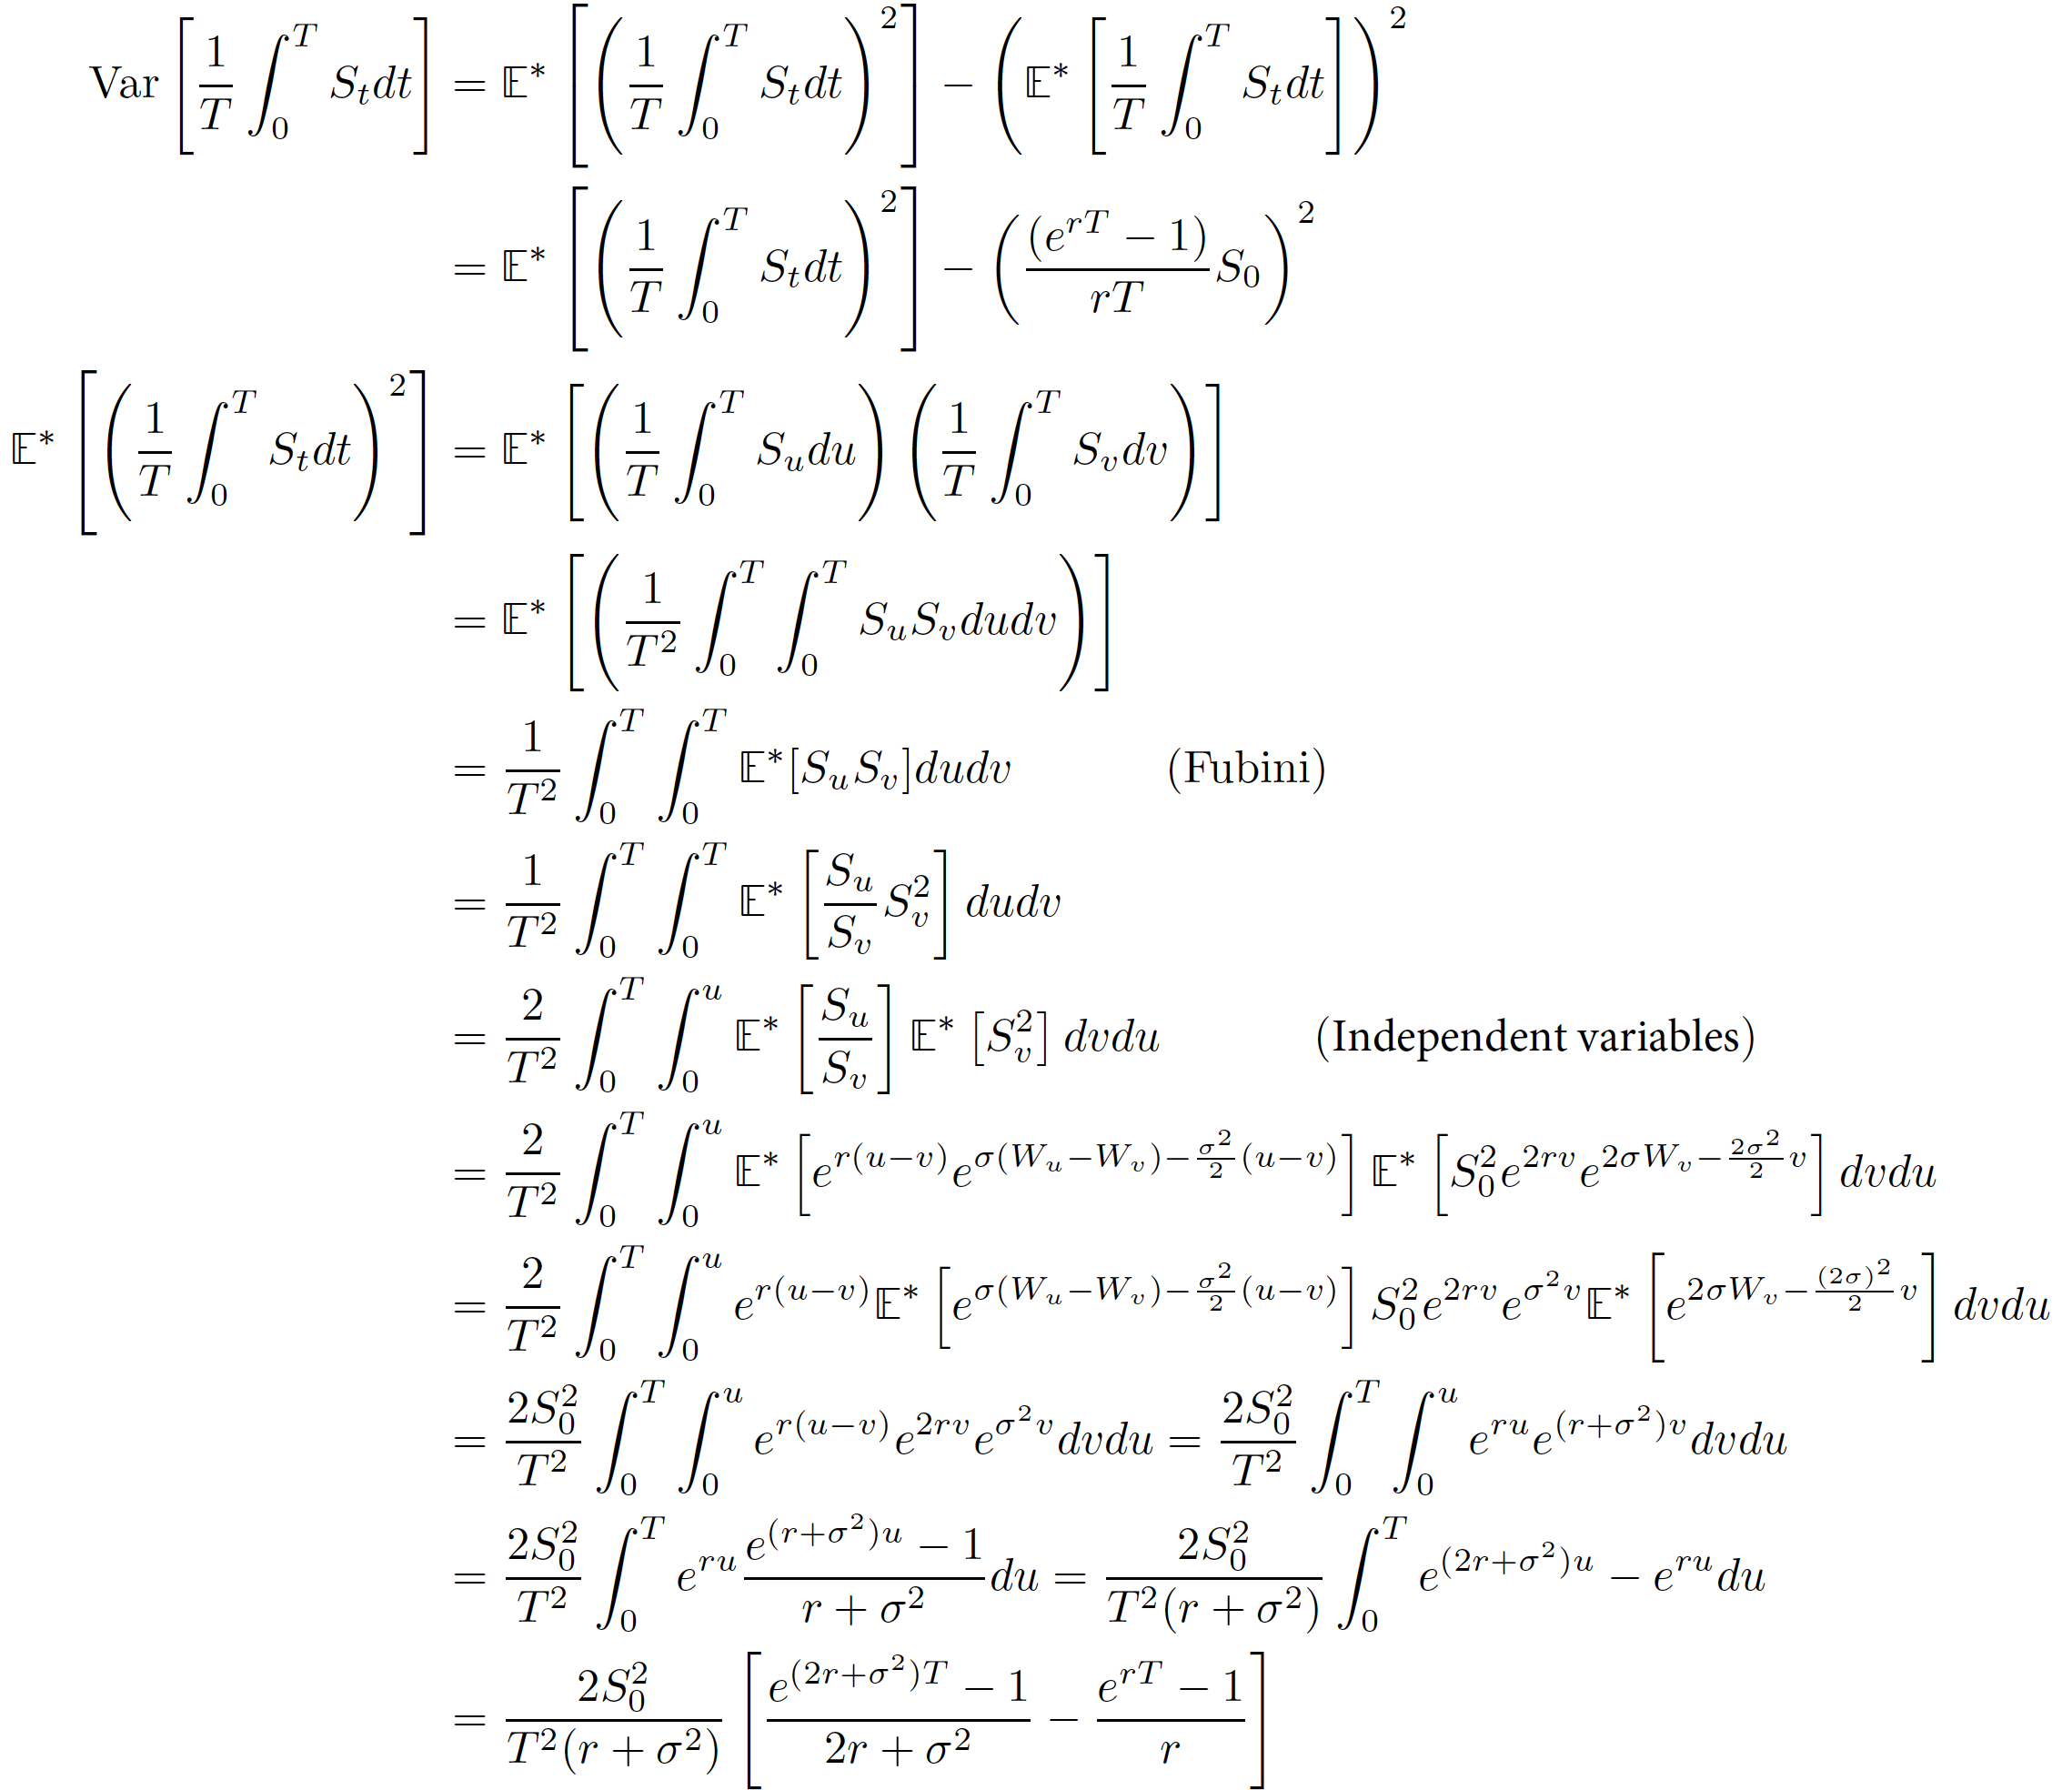

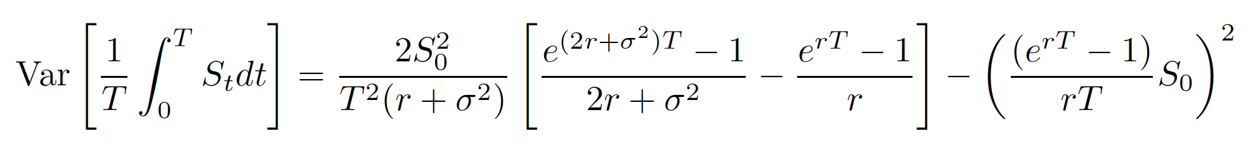>>Imported from MacTeX